# Incoherencies and wrong evaluations observed in my final exam of EE-920

Program : eMasters – Communication Systems

Roll No: 23156022

Name: Venkateswar Reddy Melachervu

1. For Q.22, I very clearly remember answering Option A. However, the evaluated response sheet I received from you shows as B. In deed I shared a message about this question in the wireless group suspecting the options A and C both are right answers.

## 

1. Dd
2. Ddd
3. ddd

Sincerely,

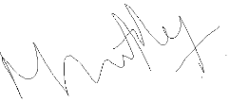

Venkateswar Reddy Melachervu